**A PROJECT REPORT ON**

**SKILL ASSESSMENT APPLICATION**

Submitted In fulfilment for the award of the degree of

**BACHELOR OF COMPUTER APPLICATION**

To

**SARVAJANIK COLLEGE OF COMMERCE AND**

**COMPUTER APPLICATION**



**Submitted by**

**Mr. Neel Motawala (SC23BCCA072)**

**Mr. Maheshgiri Goswami (SC23BCCA040)**

**Ms. Sikha Chaurasia (SC23BCCA012)**

**Under the Guidance of**

**Mr. Jaykumar Shah**

**SARVAJANIK UNIVERSITY**



**Academic year**

**(2025-2026)**

**Sarvajanik College of Commerce and Computer Application**

**April 2025**



**CERTIFICATE**

This is to certify that the project entitled **“SKILL ASSESSMENT APPLICATION”** has been carried out by **MOTAWALA NEEL (SC23BCCA072), GOSWAMI MAHESHGIRI (SC23BCCA040), CHAURASIA SIKHA (SC23BCCA012)** under my guidance in fulfilment of the degree of Bachelor of Computer Application in Department of Computer Science of 6th Semester of Sarvajanik University, Surat during the academic year 2025-26.

**DATE: __________**

**Internal Guide Head of Department**

**_____________ ___________________**

**DECLARATION**

We, the undersigned hereby declare that project report entitle **Skill Assessment Application** with special reference to **Sarvajanik College of Commerce and Computer Application** written and submitted by us in partial fulfilments of requirements for the award of Bachelor of Computer Application under the guidance of **Mr. Jaykumar Shah**, is my original work and interpretations drawn therein are based on material collected by ourselves.

**Signature:**

**Name: Motawala Neel**

**Enrollment: (SC23BCCA072)**

**Signature:**

**Name: Goswami Maheshgiri**

**Enrollment: (EC22BCCA040)**

**Signature:**

**Name: Chaurasia Sikha**

**Enrollment: (SC23BCCA012)**

**ACKNOWLEDGEMENT**

It is our pleasure to present this project of “Rental Home Management System”.

At this moment, first of all we would like to thank the respected Head of the Department of our Bachelor of Computer Application Mr. Jay Shah who gave us more detail on project.

We are also thankful to our guide Ms. (Sejal Rakholiya) and many more things are guided to our project. And finally, our sincere thanks to my batch-mate, who had provided us with innumerable discussions on many technicalities and friendly tips. Without his cordial and friendly support, this activity might be much tougher.

We are also thankful to our Parents, Friends and Others for their opinions and support in the system.

**Your Faithfully**

**Motawala Neel Goswami Maheshgiri** **Chaurasia Sikha**

**ABSTRACT**

The idea for developing a **Skillify** emerged during the period when our college faculty instructed us to undergo an internship as part of our academic curriculum. At that time, our team began evaluating our own proficiency in various programming languages to prepare for internship opportunities. However, we soon realized that there was no dedicated platform available that could effectively assess our practical knowledge and skill level in a particular programming language.

In our search for resources, we primarily relied on YouTube tutorials and interview preparation videos to understand the types of questions commonly asked in technical interviews. Although helpful, this method lacked personalization and systematic evaluation, making it difficult to accurately measure our strengths and weaknesses.

This experience led us to identify a significant gap — the absence of a comprehensive, interactive, and language-specific skill assessment platform that could help students and aspiring professionals evaluate their technical knowledge before applying for internships or jobs.

Recognizing this need, we conceptualized the idea of a **Skillify** — a platform designed to provide structured assessments, real-time feedback, and a clear understanding of one’s proficiency in different programming languages.

**Table Of Contents**

**Ch No. Content Page No.**

**1. Introduction of Project** **7**

1.1 Project Summary 8

1.2 Introduction to Project 9

1.2.1 Detail Description 9

1.2.2 Description of Each Module 9

1.2.3 Tools and Technology 10

**2. Description of the Product and Problem Analysis 16**

2.1 Project Planning 17

2.2 Hardware Requirement 20

2.3 Software Requirement 20

**3. The outline of the Solution 21**

3.1 DFD 22

3.2 E-R Diagram 23

3.3 Data Dictionary 24

**4. Test Strategies & Cases 29**

4.1 Testing 30

4.1.1 Purpose of Testing 30

4.1.2 Testing Strategy 30

**5. Snapshot 33**

**6. Advantages & Disadvantages 46**

6.1 Advantages 47

6.2 Limitation 47

**7. Conclusion 48**

**8. Bibliography 50**

**Chapter 1.**

**Introduction of Project**

**1.1 Project Summary**

**♦ Project Name: Skill Assessment Application**

**♦ Type of Application: Web based Application**

**♦ Developers: 1) Neel Motawala (SC23BCCA072)**

**2) Maheshgiri Goswami(SC23BCCA040)**

**3) Sikha Chaurasia (SC23BCCA012)**

**♦ University: Sarvajanik University**

**♦ Internal Guide: Mr. Jay Shah**

**♦ Front End: HTML, CSS, Java Script, React JS**

**♦ Back End: Node JS + Express JS**

**♦ Database: Xampp MySQL**

* 1. **Introduction to Project**
     1. **Detailed Description**

The Skill Ass is designed to evaluate a user’s knowledge and proficiency in various programming languages through both theoretical and practical assessments. The platform incorporates a user-friendly frontend interface and a robust backend system to ensure smooth performance and accurate result processing. It allows users to test their skills in different domains by attempting multiple-choice questions (MCQs) for theoretical understanding and coding challenges for practical application. This comprehensive approach helps learners identify their strengths and areas for improvement, making the application an effective tool for students and professionals preparing for technical interviews or internships.

* + 1. **Detailed Description of Module**

**Admin:**

* Admin can create, update, and archive tests, sections, and question banks.
* Set test settings: duration, cut-off scores, negative marking, randomization, and proctoring rules.
* Manage user roles and permissions (Admin / Examiner ).
* Track live test sessions and view integrity flags (tab-switch, suspicious activity).
* View scorecards, pass/fail status, and detailed analytics by test, batch, or candidate.
* Handle support tickets and resolve technical issues to keep the platform running smoothly.
* Set branding: logo, color theme, custom domains, and email templates.
* Ensure data privacy, backups, and compliance (consent logs, audit trails, IP/device.

**User:**

* The system supports user registration and login using email, phone OTP, and Google for seamless access.
* Users can explore all available skill tests on an “Explore Tests” page, categorized by skill type, difficulty level.
* Users can attempt tests by selecting a skill category and test level. The system manages test duration, cut-off scores, negative marking, and integrity monitoring (tab switch alerts,etc.).
* After completion, users can view detailed scorecards, performance analytics, and feedback on the “My Results” page.
* The module includes profile management, where users can update personal details, skills, and view their test history.
* A navigation bar provides quick access to all major sections — Home, Explore Tests, My Results, and Profile.

**Tools and Technology**

**1.Front-End:**

**1. HTML**

HTML is an acronym which stands for Hyper Text Markup Language which is used for creating web pages and web applications. Let's see what is meant by Hypertext Markup Language, and Web page.

Hyper Text: Hypertext simply means "Text within Text." A text has a link within it, is a hypertext.  Whenever you click on a link which brings you to a new webpage, you have clicked on a hypertext.  Hypertext is a way to link two or more web pages (HTML documents) with each other.  Markup language: A markup language is a computer language that is used to apply layout and formatting conventions to a text document. Markup language makes text more interactive and dynamic. It can turn text into images, tables, links, etc.

Web Page: A web page is a document which is commonly written in HTML and translated by a web browser. A web page can be identified by entering an URL. A Web page can be of the static or dynamic type. With the help of HTML only, we can create static web pages.

**2. CSS**

CSS stands for Cascading style sheets. It describes to the user how to display HTML elements on the screen in a proper format. CSS is the language that is used to style HTML documents. In simple words, cascading style sheets are a language used to simplify the process of making a webpage.

CSS is used to handle some parts of the webpage. With the help of CSS, we can control the colour of text and style of fonts, and we can control the spacing between the paragraph and many more things. CSS is easy to understand but provides strong control on the Html documents.CSS is combined with HTML.

**Advantages of CSS:**

* **Faster page speed:** It has a faster page speed than other code's page speeds. With the help of the CSS rule, we can apply it to all occurrences of certain tags in HTML documents.
* **Better user experience:** CSS makes a webpage very attractive to the eyes. Also, CSS makes it user friendly. When the button or text is in a proper format, it improves the user experience.

**Compatibility:** Compatibility is very important in today's age. If we create any webpage, it should be very responsive and user-friendly. CSS is used with Html to make webpage design responsive.

**3. JAVASCRIPT**

JavaScript is a lightweight, cross-platform, single-threaded, and interpreted compiled programming language. It is also known as the scripting language for webpages. It is well-known for the development of web pages, and many non-browser environments also use it.

JavaScript is a weakly typed language (dynamically typed). JavaScript can be used for Client-side developments as well as Server-side developments. JavaScript is both an imperative and declarative type of language. JavaScript contains a standard library of objects, like Array, Date, and Math, and a core set of language elements like operators, control structures, and statements.

With technology, browsers have improved to the extent that a language was required to create robust web applications. When we explore a map in Google Maps then we only need to click and drag the mouse. All detailed view is just a click away, and this is possible only because of JavaScript. It uses Application Programming Interfaces (APIs) that provide extra power to the code. The Electron and React are helpful in this department.

**Advantages of JAVASCRIPT:**

* **Saves time and bandwidth:** Regardless of where you host JavaScript, it always gets executed on the client environment to save lots of bandwidth and make the execution process fast.
* **Easily send HTTP requests:** In JavaScript, XMLHttpRequest is an important object that was designed by Microsoft. The object calls made by XMLHttpRequest as an asynchronous HTTP request to the server to transfer the data to both sides without reloading the page

There is no need to correct individual pages in a CSS style sheet. If we fix a CSS style sheet, it will automatically update the other CSS style sheet.

**Disadvantages of JAVASCRIPT:**

JavaScript is usually interpreted differently by different browsers. This makes it somewhat complex to read and write cross-browser code

Though some HTML editors support debugging, it’s not as efficient as other editors like C/C++ editors. Hence difficult for the developer to detect the matter.

No matter what proportion fast JavaScript interprets, JavaScript DOM (Document Object Model) is slow and can be a never-fast rendering with HTML.

**4.ReactJS**

React.js, commonly known as **React**, is a free and open-source JavaScript library used for building user interfaces (UIs) or UI components. Developed and maintained by Meta (formerly Facebook) and a community of developers, it's a foundational tool for creating dynamic, single-page applications (SPAs).

The core of React is the concept of a **component**. A component is a self-contained, reusable piece of a UI. For example, a website might have components for a navigation bar, a search bar, a button, and a user profile card. This modular approach simplifies development, making it easier to build and maintain complex UIs. You can think of components like LEGO bricks; you build complex structures by snapping together smaller, reusable pieces.

React uses a **declarative** approach to building UIs. Instead of telling the application *how* to update the UI step-by-step (imperative), you simply describe *what* the UI should look like for a given state. When the data changes, react automatically updates the UI to reflect the new state. This makes your code more predictable and easier to debug.

React enforces a **one-way data flow**, often referred to as "top-down." Data and state are passed from a parent component down to its children. This makes the data flow predictable and helps in managing state across your application. While child components can communicate back to parents, they do so through events or callbacks, maintaining the clear, one-directional flow.

**Advantages of ReactJS:**

* **Enhanced Performance with Virtual DOM:** One of the most significant advantages of React is its use of a Virtual DOM (Document Object Model).
* **Rich User Interfaces:** React is highly effective at creating dynamic and interactive UIs. Its declarative syntax and efficient rendering allow developers to build rich, engaging digital experiences that respond quickly to user input. This ability to create a seamless and intuitive user experience is a major factor in improving user satisfaction and loyalty.

**Disadvantages of ReactJS:**

* **High Learning Curve for Beginners:** Although Redact’s core concepts are relatively simple, a beginner might find the overall ecosystem overwhelming. The learning curve is steep for developers who are not already comfortable with modern JavaScript features.
* **Performance Issues with Large Applications (if not optimized):** While the Virtual DOM is a performance advantage, it's not a silver bullet. If a React application is not built with performance optimization in mind, issues can arise. For instance, frequent and unnecessary re-renders of components can impact performance, especially in large and complex applications with deeply nested component trees.

**2.Back-End:**

**1.Node JS**

Node.js is an open-source, cross-platform JavaScript runtime environment that allows developers to run JavaScript code outside of a web browser. It's built on the Chrome V8 JavaScript engine and is primarily used for building fast, scalable, and efficient server-side applications.

Node.js is built for concurrency, meaning it can handle multiple operations at once. It uses a **non-blocking I/O (Input/Output)** model, which allows it to process requests without waiting for I/O operations (like file reads or database queries) to complete. This is a significant advantage for applications that need to handle many concurrent connections, such as real-time chat applications or APIs.

Node.js comes with NPM, the world's largest ecosystem of open-source libraries. NPM makes it easy for developers to discover, share, and reuse code. This vast collection of packages accelerates development and provides solutions for everything from building web frameworks (like Express.js) to working with databases.

**Advantages of NodeJS:**

* **High Performance and Scalability:** Node.js is renowned for its exceptional performance. It uses a single-threaded, non-blocking I/O model, which enables it to handle a large number of concurrent connections without creating a new thread for each one.
* **Full-Stack JavaScript:** One of Node.js's most significant advantages is the ability to use JavaScript for both the front-end and back-end development.

**Disadvantages of NodeJS:**

* **Not Suitable for CPU-Intensive Tasks:** Node.js, despite its many advantages, has several drawbacks that can make it unsuitable for certain types of applications. Here are its main disadvantages:
* **Poor Performance for Relational Databases:** While Node.js works very well with non-relational databases (like MongoDB), it can be less performant when dealing with complex relational databases (like MySQL or PostgreSQL).

**2.ExpressJS**

Express.js is a minimalist and flexible Node.js web application framework that provides a robust set of features for building web and mobile applications. It's the de facto standard for building the back end of applications with Node.js.

Express.js provides an easy way to define routes, which are the different URLs (or endpoints) that an application can handle. You can set up different routes for various HTTP methods like GET, POST, PUT, and DELETE.

Middleware functions are the core of Express.js. They are functions that have access to the request object (req), the response object (res), and the next middleware function in the application’s request-response cycle. They can execute code, make changes to the request and response objects, and end the request-response cycle. Common uses of middleware include logging requests, parsing JSON data, or handling authentication.

**Advantages of ExpressJS:**

* **Minimal and Flexible Design:** Express.js is a minimalist, unopinionated framework. It provides a thin layer of core web application features, but doesn't force a specific project structure or architecture on you.
* **Fast Server-Side Development:** Express.js provides ready-to-use functions and an easy-to-use API that significantly speeds up the process of building web servers.

**Disadvantage of ExpressJS:**

* **Middleware Reliance and Dependency Management:** Express.js is a minimalist framework, meaning it lacks many built-in features for things like database interactions, authentication, or validation. Instead, it relies heavily on third-party middleware.

**3.Database:**

**Xampp MySQL:**

* XAMPP is a free, open-source software package that provides an easy way to set up a local web server environment on your computer. It includes several key components used in web development—Apache (for hosting web pages), MySQL (for database management), PHP, and Perl.
* The MySQL component in XAMPP allows developers to create, manage, and interact with databases locally, which is essential for building and testing dynamic websites and applications that require data storage. MySQL in XAMPP can be accessed through tools like phpMyAdmin, a web-based interface that simplifies tasks such as creating databases, running SQL queries, and managing users.
* This makes XAMPP an ideal solution for beginners and professionals who want to develop, test, and debug web applications without needing an internet connection or a remote server.

**Advantages of Xampp MySQL:**

* **Easy Installation and Setup:** XAMPP provides a one-click installation of MySQL along with other components like Apache and PHP.No complex configuration is required — perfect for beginners or quick setup on local machines.
* **Cross-Platform Support:** XAMPP is available for Windows, macOS, and Linux, making it highly versatile.You can maintain consistent environments across different operating systems.

**Disadvantages of Xampp MySQL:**

* **Heavy Package (All-in-One Installation):** XAMPP installs Apache, MySQL, PHP, and more — even if you only need MySQL.This can make it **resource-heavy** and unnecessary for users who want only one component.
* **Manual Start/Stop Management:** You have to manually start MySQL through the XAMPP Control Panel. If not configured properly, it may fail to start or conflict with other services running on port 3306.

**Chapter: 2.**

**Description of Project**

**&**

**Problem Analysis**

**2.1 Project Planning**

**2.1 Project Development Approach**

**The Prototype Model**

The **prototype model** is a type of **software development model** in which a **working prototype (early sample or mock-up)** of the system is built, tested, and reworked until it meets the user’s requirements. It allows developers and clients to **interact with a preliminary version** of the software early in the development process. This helps users better understand how the final system will look and function. The prototype serves as a tool for gathering feedback and clarifying requirements, reducing misunderstandings between users and developers. Once the users are satisfied with the prototype, it is used as a basis for developing the final system. This model is especially useful when the exact requirements of the project are **not clearly defined** at the beginning.

**Prototype Model Design**

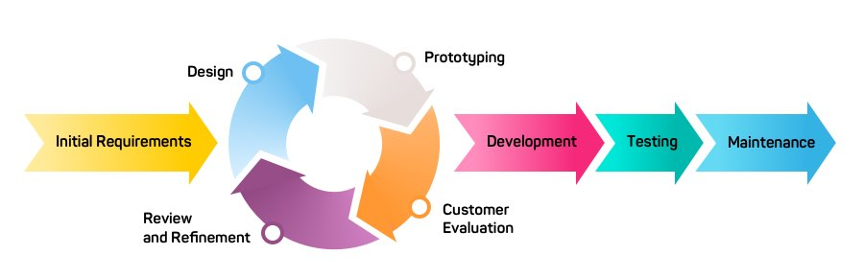

In the context of Skill Assessment Application, let's break down the Prototype development model, detailing how it would be applied throughout its development lifecycle:

**1. Project Initiation**

The primary objective of the **Skillify** project is to create a platform for **“SKILL CHECK FOR REAL SUCCESS.”**. The team, consisting of Sikha Chaurasia, Neel Motawala, and Maheshgiri Goswami, will use a **Prototype model** for development. This model focuses on building an initial prototype of the system to demonstrate its functionality and gather user feedback. Based on this feedback, the prototype is refined and improved through multiple iterations until it evolves into the final, fully functional system.The project's core logic is inspired by W3School, while the UI/UX was independently designed.

**2. Planning Phase**

The project's planning phase includes creating an **ER-Diagram** and a **Data Flow Diagram (DFD)**. The ER-Diagram visualizes the relationships between entities like users, course, admin, and questions. The DFD illustrates how data flows between the user interface, application logic (API), and the Xampp MySQL database.

**3. Development and Iteration**

The development of the Skillify application is broken down into distinct parts, each with its own set of requirements and components.

**Part 1: Minimum Viable Product (MVP)**

This part focuses on building the essential features for the user, creating a working MVP.

* **Requirements:**
  + **User Authentication:** The system must include user registration and login functionalities.
  + **Venue Browsing:** Users should be able to see a home page with Different courses and an explore page to view all types courses.
  + **Testing Process:** The application must have a Test details page and a types of test page for users to view questions and attempt test.
* **Components & Pages:** The front-end will include components and pages such as Navbar, AuthPage, HomePage, ExplorePage, TestPage,ResultPage, and ProfilePage.

**Part 2: Admin Platform**

Building on the MVP, the part iteration expands the platform to include functionalities for administrators.

* **Requirements:**
  + **Admin Control:** An admin panel will be implemented to allow administrators to approve or decline test.

**4. Continuous Delivery and Improvement (Beyond part 2)**

Subsequent prototype will focus on continuous improvement and adding more features based on user feedback. These will likely include:

* **Enhanced Features for User:** This would involve implementing features like real-time Checking, notifications. The DFD for the user shows processes for login, Enroll in course,Attempt test, view profile & result and submitting reviews.
* **Testing and Refinement:** The project will incorporate a continuous testing strategy centred on **unit, component, integration, and custom hook testing** to ensure the user interface is reliable and correct.

**Benefits of the Prototype Model for Skillify:**

* **Early Functionality:** The model starts with a prototype of requirements to create a simple, working version of the system. For Skillify, this means delivering a **Minimum Viable Product (MVP)** in the first , which includes essential features like user authentication, course browsing, and a Testing page. This allows the core functionality to be tested and used by early adopters.
* **User Feedback and Improvement:** Instead of developing the complete system at once, the Prototype Model emphasizes creating an early working model to demonstrate key functionalities. This allows the development team to gather user feedback, understand their requirements more clearly, and refine the prototype accordingly. For example, after presenting the initial prototype, the team can enhance it by improving the user interface and adding additional modules based on user suggestions.
* **Reduced Risk:** By building the project in successive cycles, the team can identify and address potential issues early on. This minimizes the risk of a project failing due to unforeseen problems that might only be discovered late in a traditional, waterfall-style development model.
* **Early Visualization:** The prototype model enables faster development of an initial working version of the system, allowing users to visualize the core functionality early in the process and provide feedback for further improvement.
  1. **Hardware Requirement**

**Minimum Hardware Requirement**:

* **Processor:** Dual Core (Intel i3 / AMD equivalent) or higher
* **RAM:** 4 GB (minimum), 8 GB recommended for smooth development
* **Storage:** 2 GB free (for Node.js, npm packages, dependencies)
* **Graphics:** Basic integrated graphics is sufficient
* **Display:** 1280 × 720 or higher

**2.3 Software Requirement**

**The Tools & Technology used in preparing this system are:**

**Operating System:**

Windows 10 or later (64-bit) macOS 10.14 (Mojave) or later

Linux (Ubuntu 20.04 LTS or later recommended)

**Node.js:**

Minimum: Node.js v16.x

Recommended: Node.js v18.x or v20.x (LTS) for stability & security

**Package Manager:**

npm (comes with Node.js) OR yarn

**IDE/Editor:**

VS Code (recommended)

**Database:**

MySQL (Xampp)

**Chapter: 3**

**The Outline of Solution**

**3.1 Data Flow Diagram (DFD)**

**Level 0: Context Diagram (Top)**

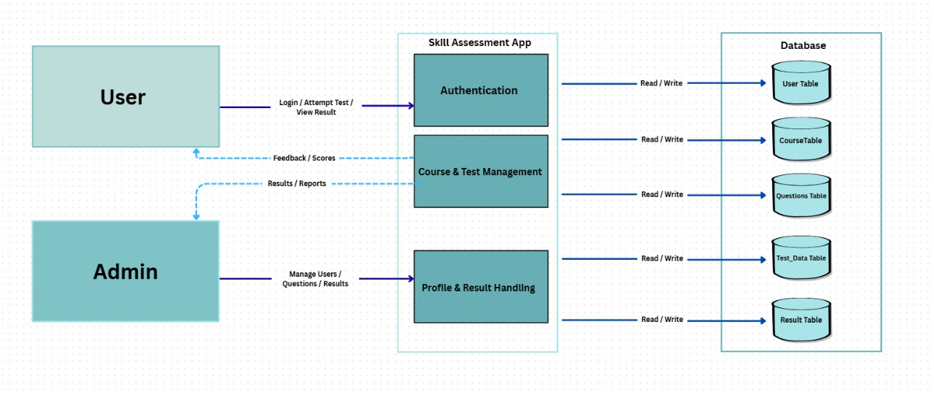

**Level 1: (ADMIN)**

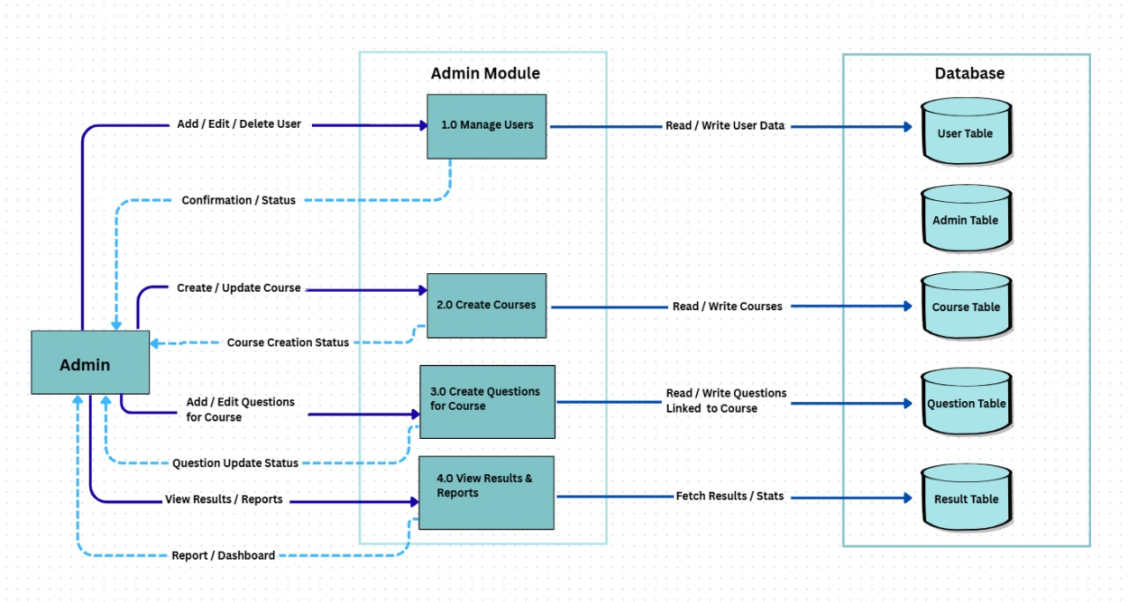

**Level 1: (User)**

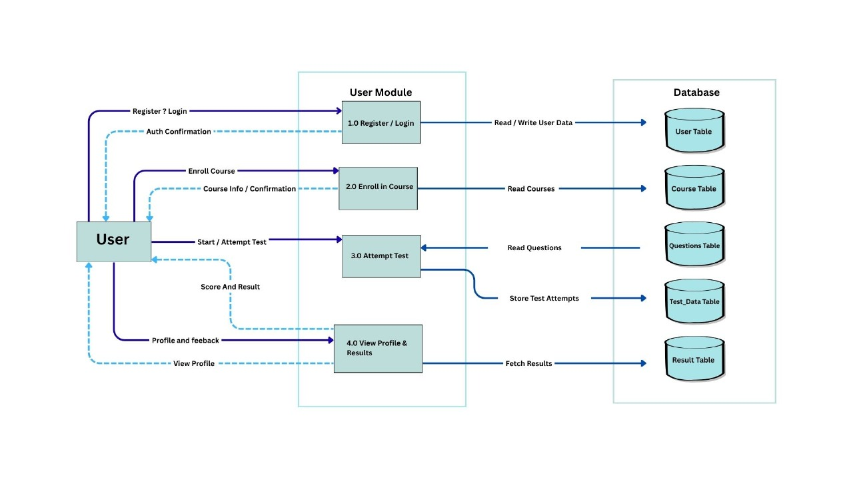

**3.2 Entity Relationship Diagram (ERD)**

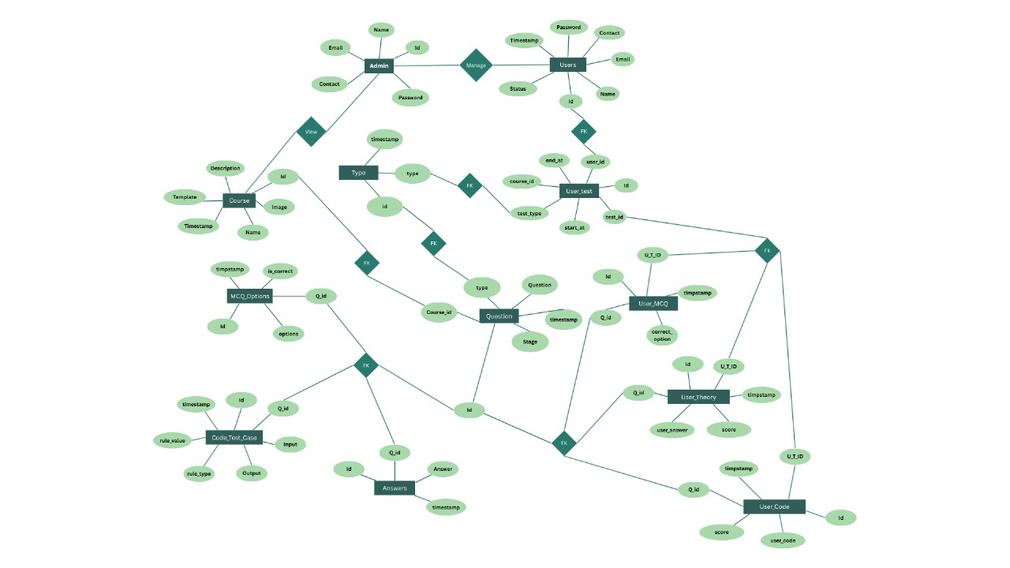

**3.3 Data Dictionary (System Database)**

**3.3.1 Data Dictionary:**

* 1. **Main table**

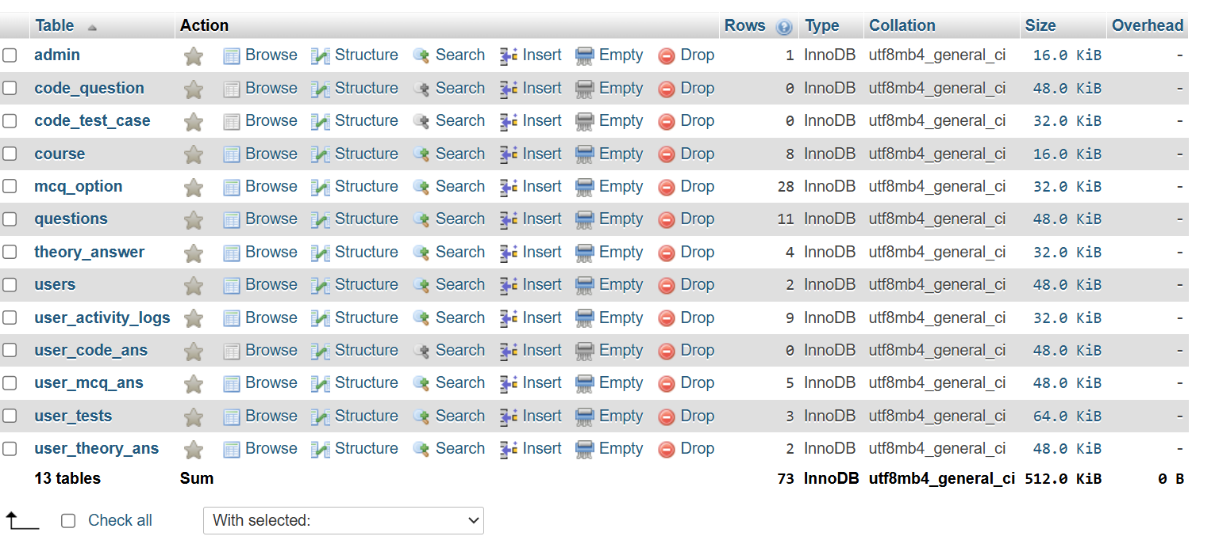

* 1. **Admin table**

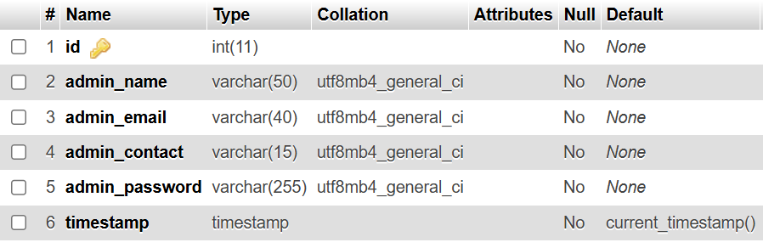

* 1. **Code-question table**

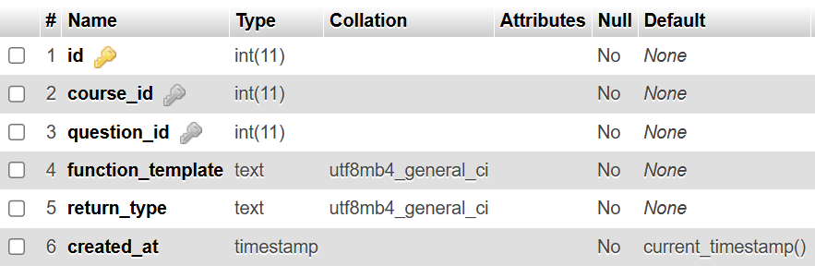

* 1. **Code-test-case table**

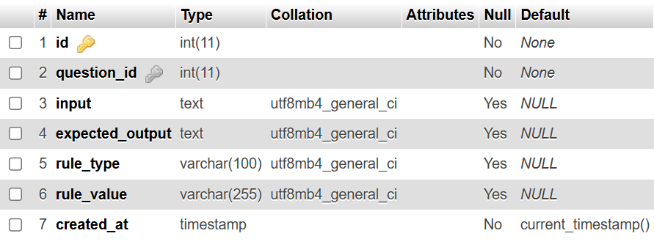

* 1. **Course table**

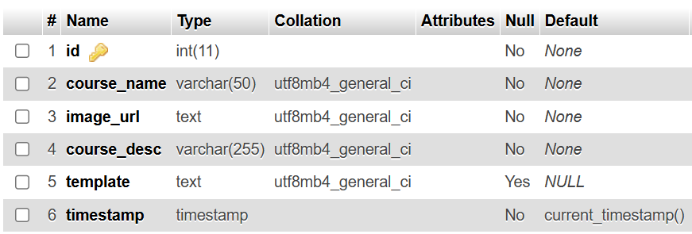

* 1. **Mcq-option table**

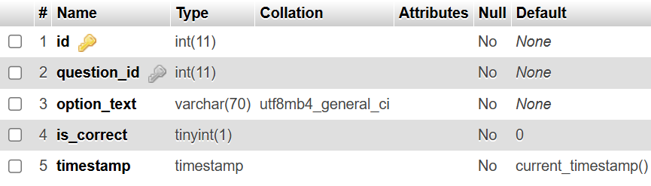

* 1. **Questions table**

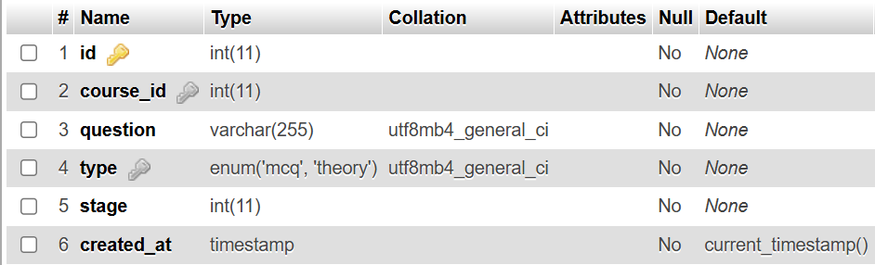

* 1. **Theory-answer table**

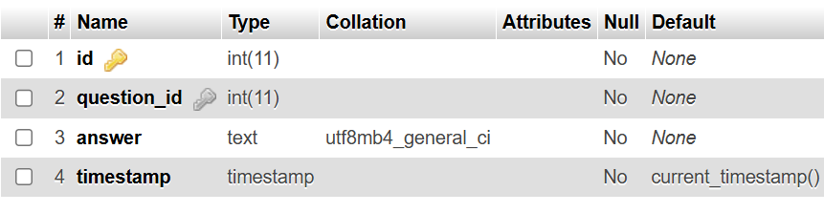

* 1. **Users table**

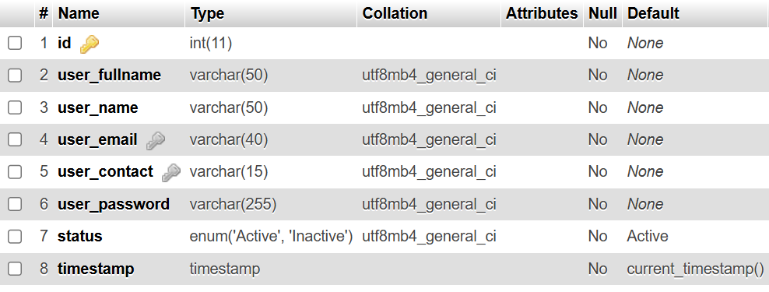

* 1. **User-activity-logs table**

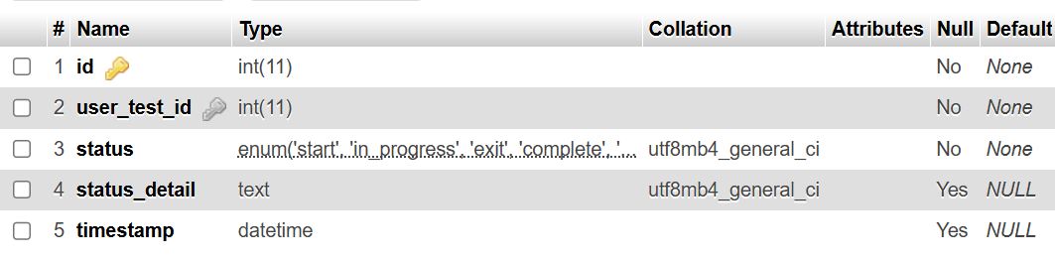

* 1. **User-code-answer table**

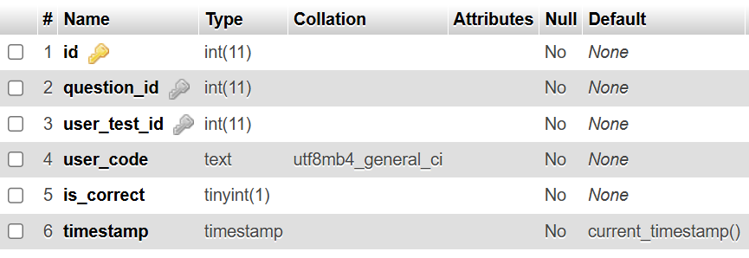

* 1. **User-mcq-answer table**

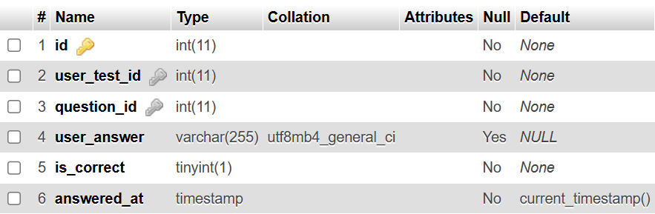

* 1. **User-tests table**

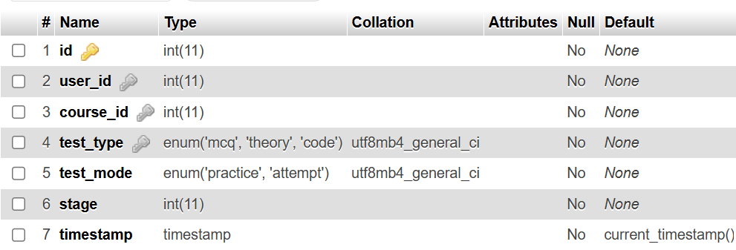

* 1. **User-theory-answer table**

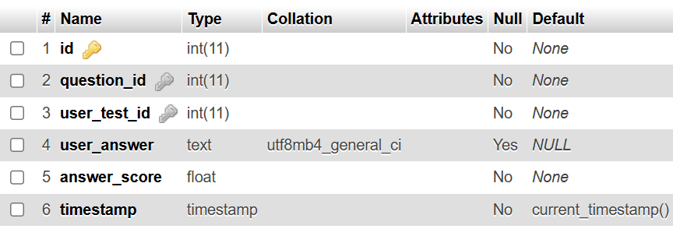

**Chapter: 4**

**Test Strategies & Cases**

# Testing

### Testing

Testing for a Skill Assessment Application is the process of evaluating the software application to ensure that it meets specified requirements, functions correctly, and provides a reliable user experience.

This involves systematically testing various components and features of the Skill Assessment Application, such as quiz functionality, coding test execution, result evaluation, and user authentication, to identify defects, ensure data accuracy, and validate overall system performance.

### Purpose of Testing

There are two fundamental purposes of testing: verifying procurement specifications and managing risk. First, testing is about verifying that what was specified is what was delivered: it verifies that the product (system) meets the functional, performance, design, and implementation requirements identified in the

procurement specifications. Second, testing is about managing risk for both the acquiring agency and the system’s vendor/developer/integrator. The testing program is used to identify when the work has been “completed”

so that the contract can be closed, the vendor paid, and the system shifted by the agency into the warranty and maintenance phase of the project.

### Testing Strategy

This testing strategy is designed to ensure that the Skill Assessment Application operates correctly, meets user requirements, and maintains performance, security.

Test complete workflows from user login to complete course testing.

Gather feedback from testing phases to improve the system and testing processes continuously.

Focus on high-risk areas such as user data management.

Hold retrospectives to identify improvements for future testing cycles.

**Step of Functional Testing**

Initially, the functional requirements and specifications of the application are reviewed to understand the expected behavior of each feature. The tester verifies whether every function of the system operates in accordance with these requirements.

● Test scenarios are designed based on functional specifications and user requirements.  
● Software tester identifies input data and determines the expected outcomes for each function.  
● Test cases are created to validate individual features such as login, user registration, and assessment submission.  
● The test cases are executed to check whether each function performs as intended.  
● The actual results are compared with the expected results to identify any deviations.  
● Any defects found during testing are reported, resolved, and the affected functionalities are re-tested to ensure proper operation.

**Types of Functional Testing**

There are many types of Functional Testing, but the following are the prominent ones –

**Unit Testing** – Test individual components or functions of the application to ensure that each part performs as expected. It helps identify issues at an early stage of development.

**Smoke Testing** – Verify that the basic and critical functionalities of the application work correctly after a new build or update, ensuring system stability before proceeding with further testing.

**Integration Testing** – Check how different modules or features of the application interact with each other to confirm that data flows correctly between them.

**System Testing** – Validate the complete and integrated system to ensure that it meets all specified requirements and performs the intended operations accurately.

**User Acceptance Testing (UAT)** – Conducted from the end-user’s perspective to confirm that the system meets business needs and delivers the expected user experience before deployment.

### **Test Case 1:**

**Test form:** Registration Page

**Test Case Name:** Ensure all fields in Registration Page.

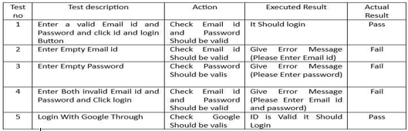

### **Test Case 2:**

**Test form:** Login Page

**Test Case Name:** Ensure Correct Email id and Password in login.

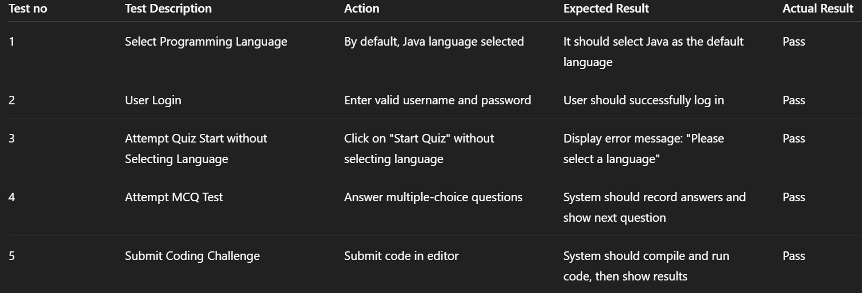

**Chapter: 5**

**Snapshot**

**Landing Page**

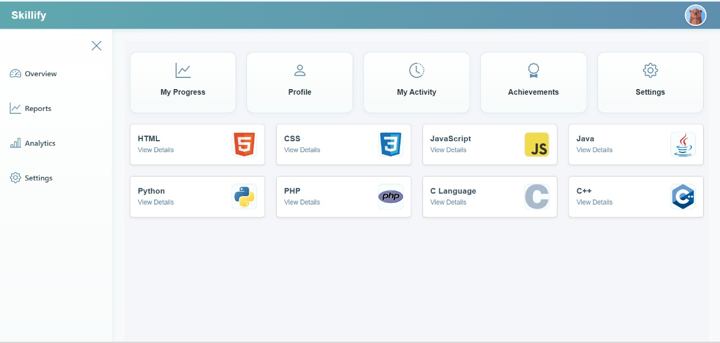

**Login**

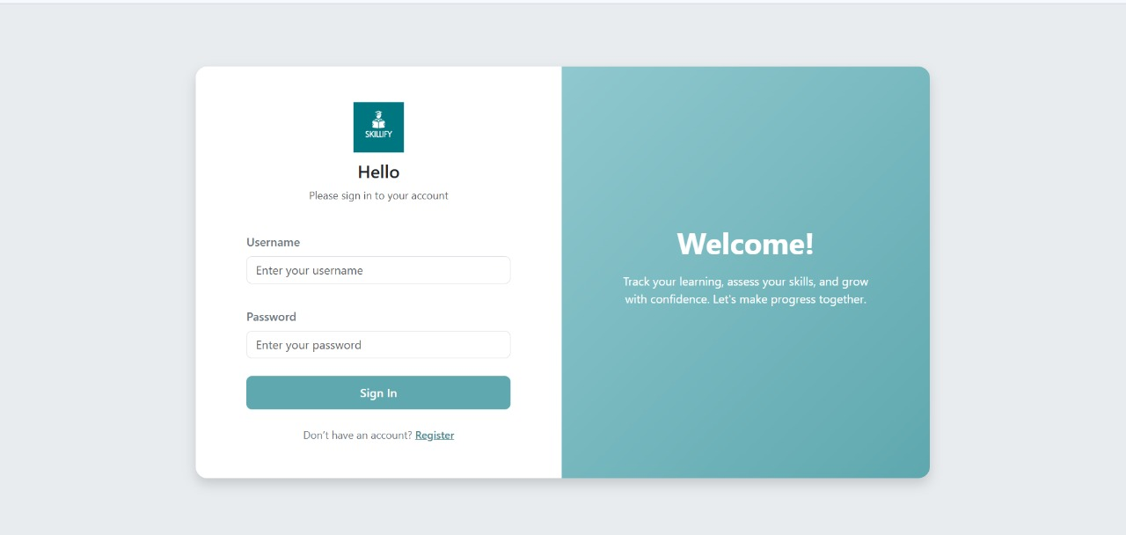

**Sign up**

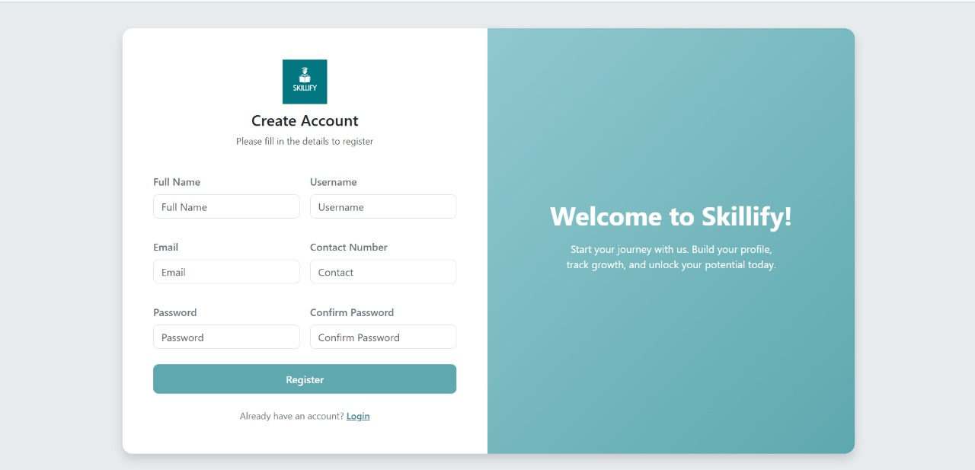

**Mcq question**

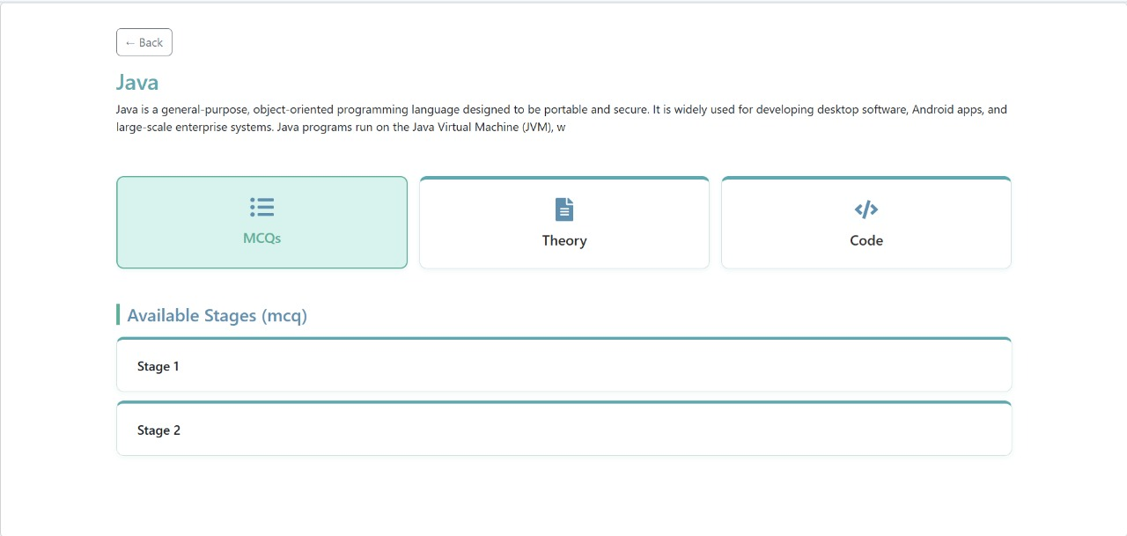

**Mcq question**

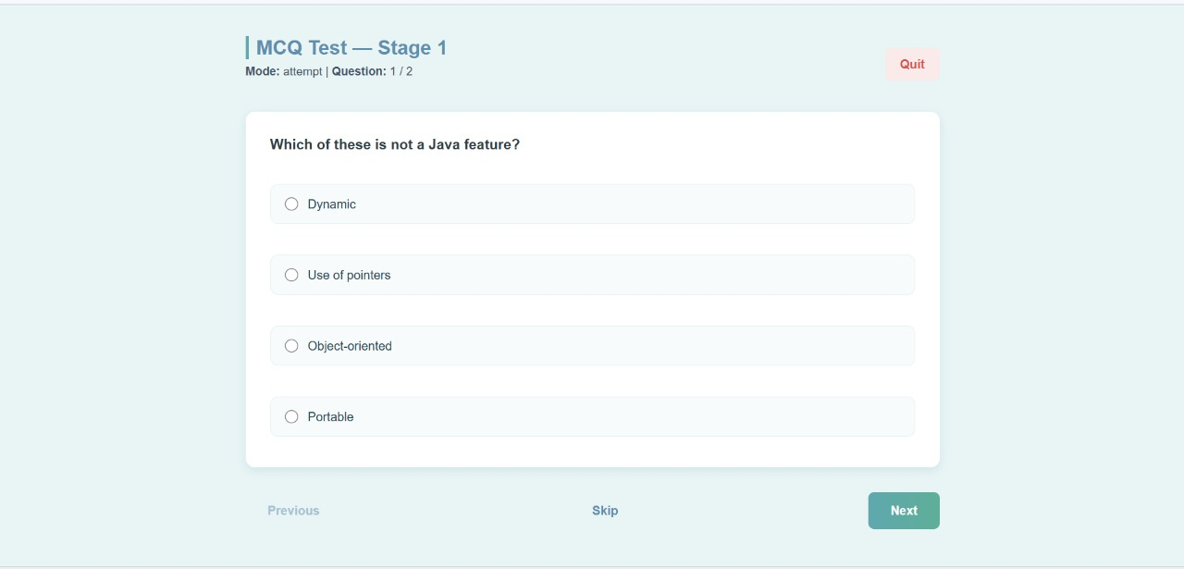

**Preview Page**

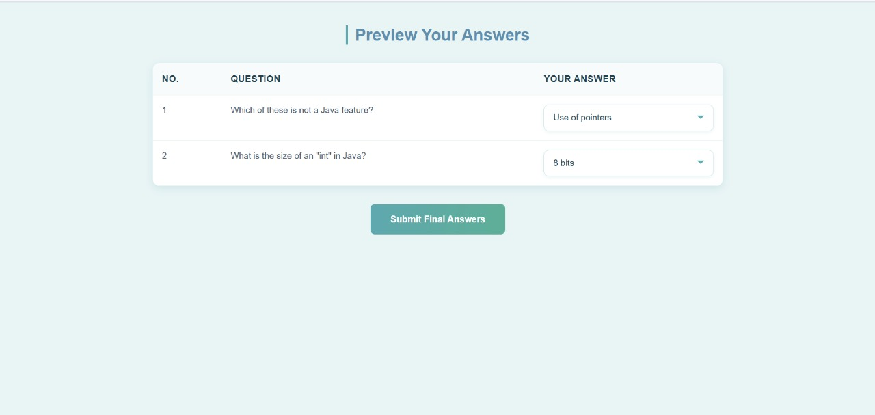

**Result**

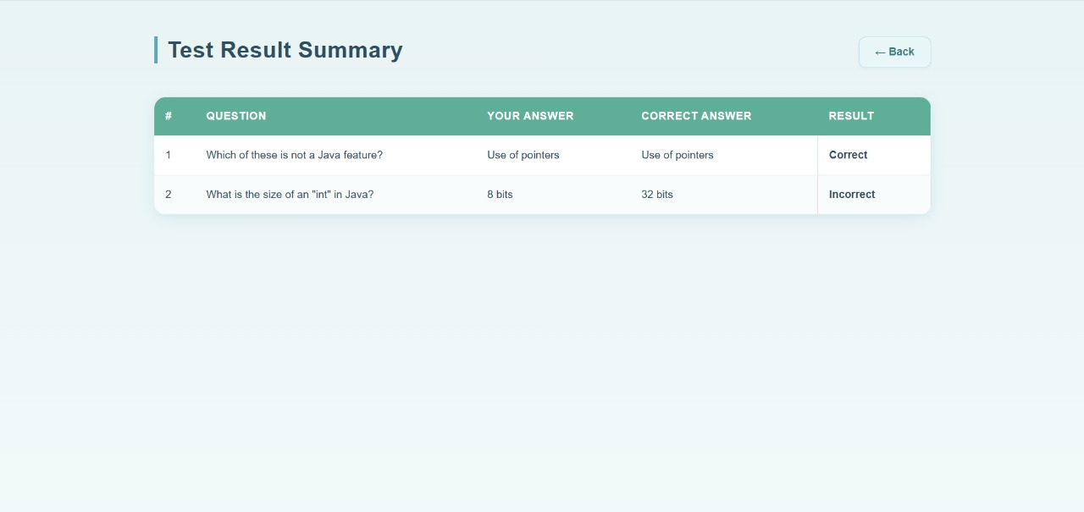

**Theory question**

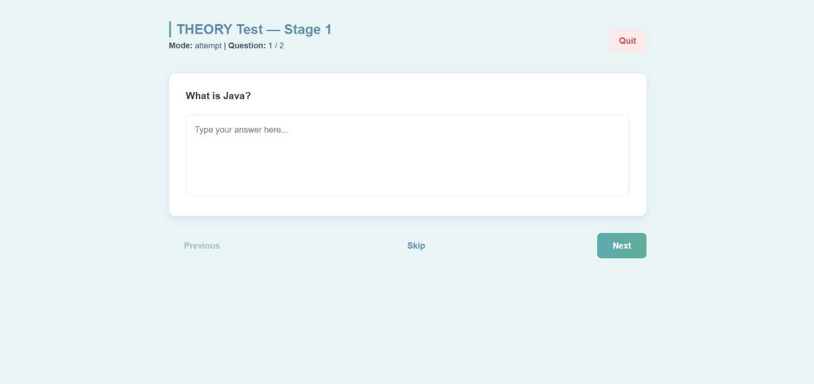

**Theory Preview**

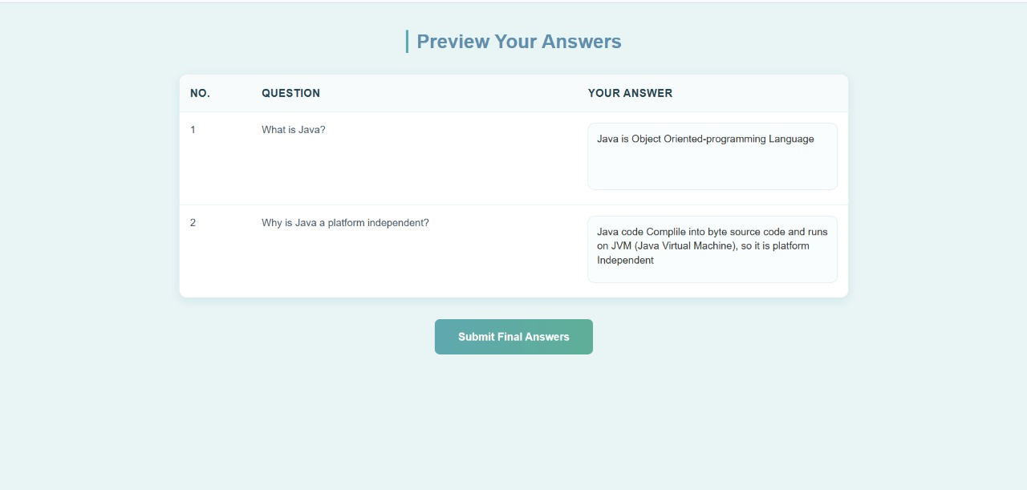

**Theory Test Result**

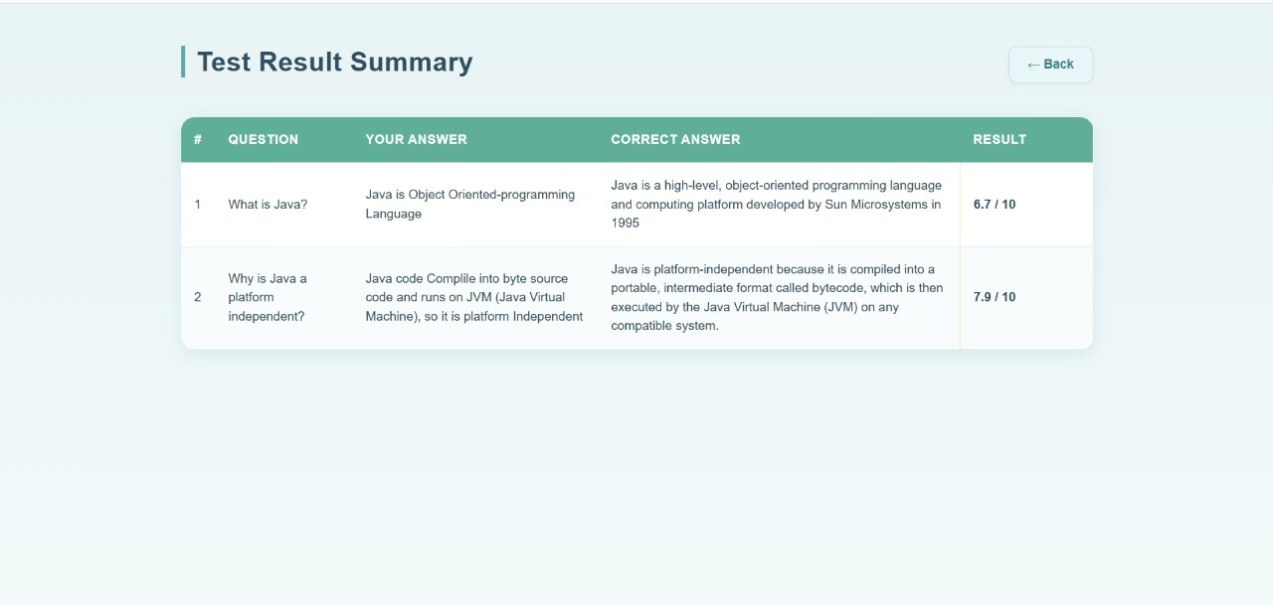

**Profile Page**

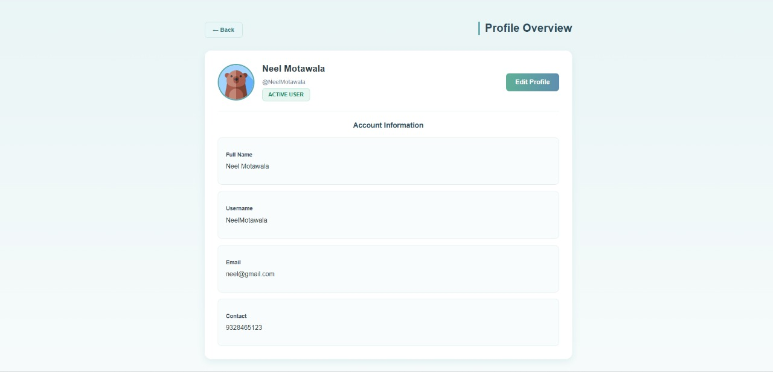

**Admin’s page**

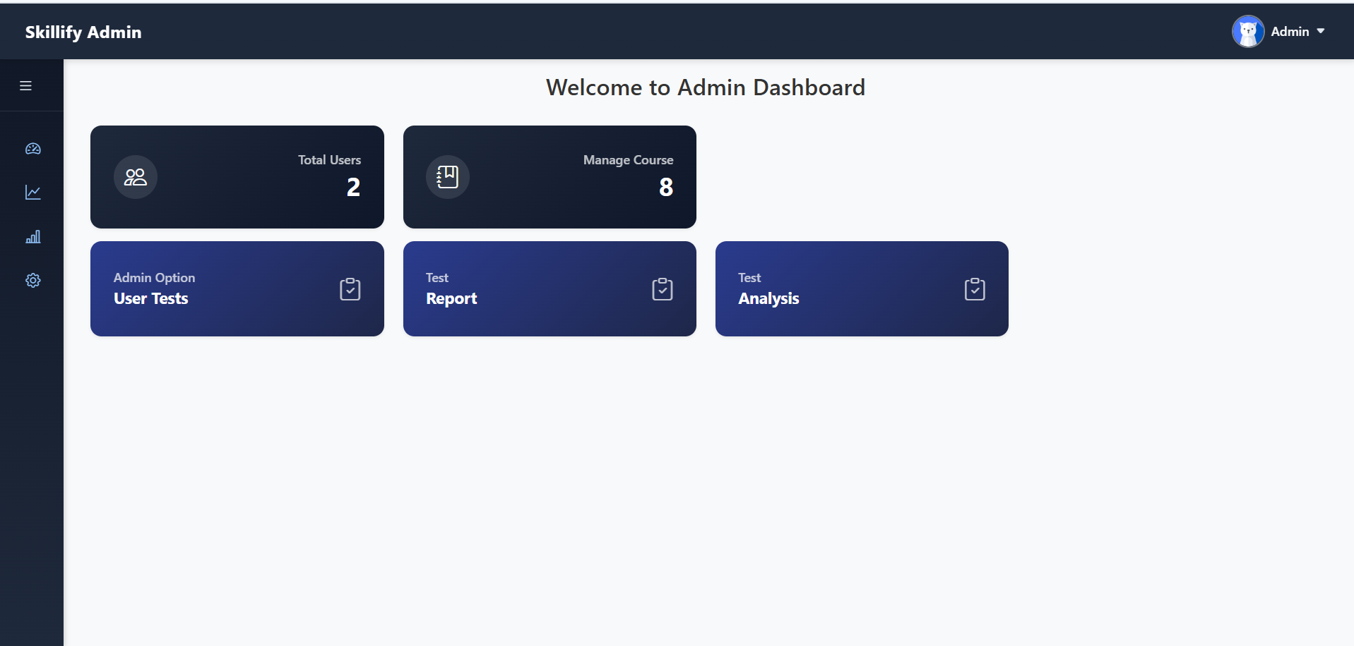

**User’s List**

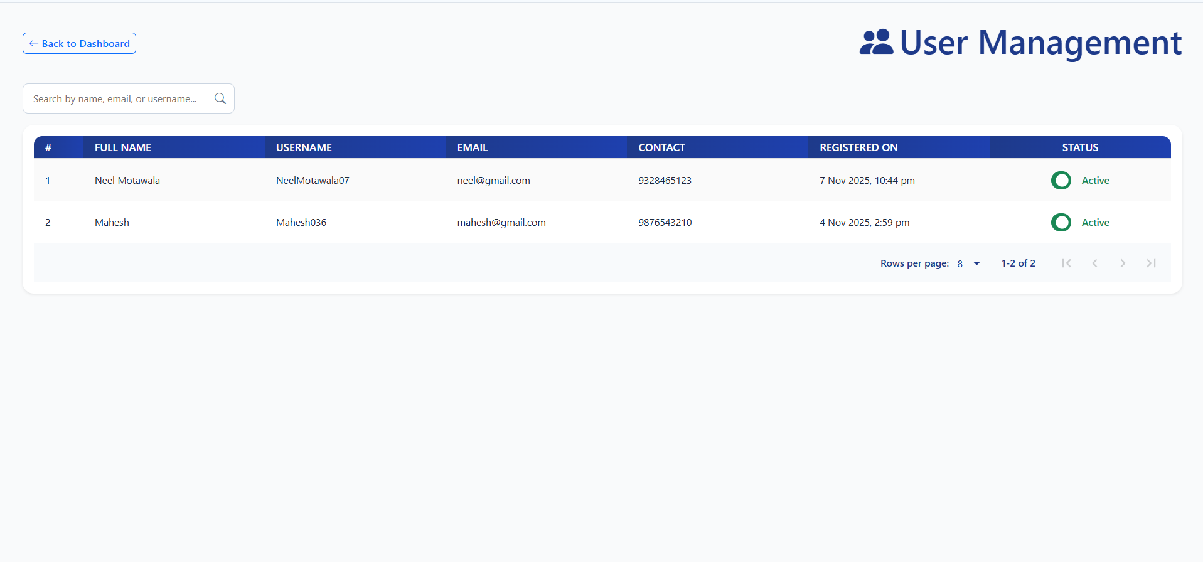

**User’s Test**

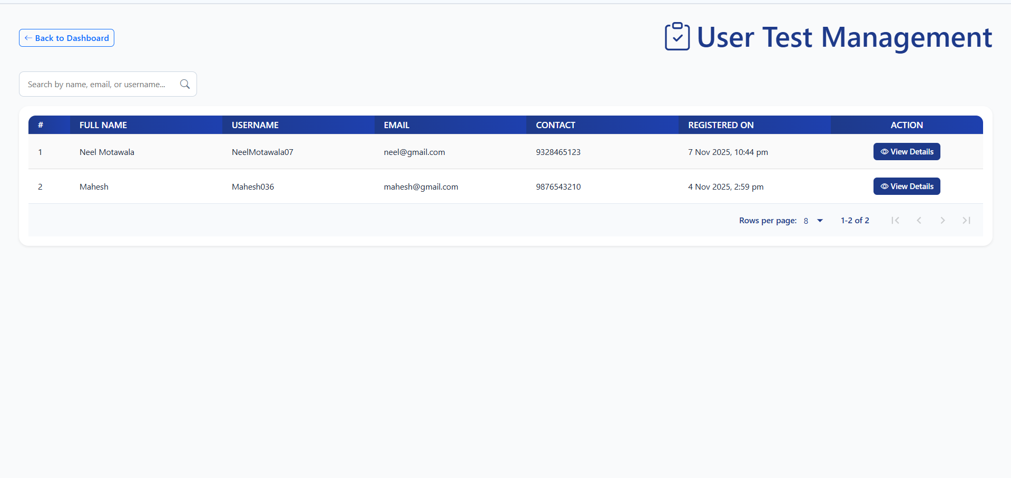

**User Test Detail**

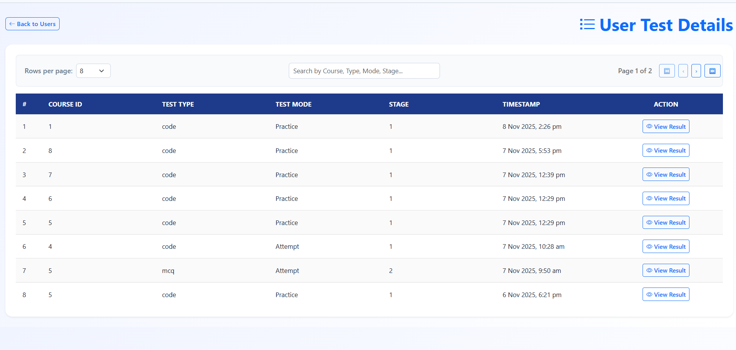

**Course Management**

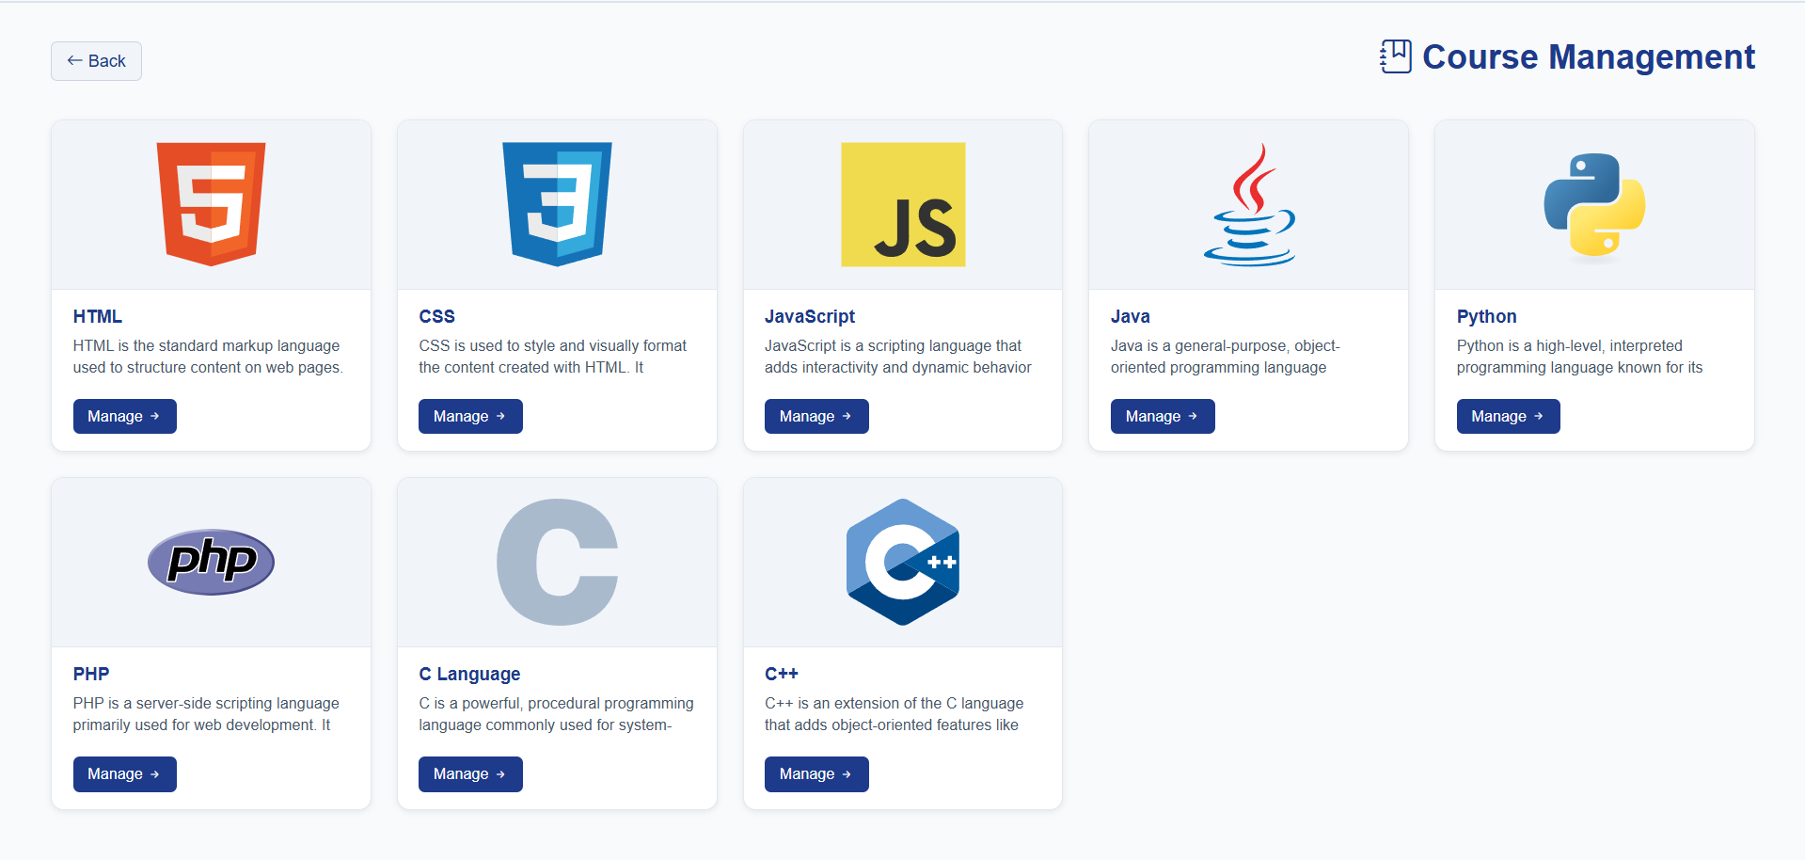

**Manage Questions:**

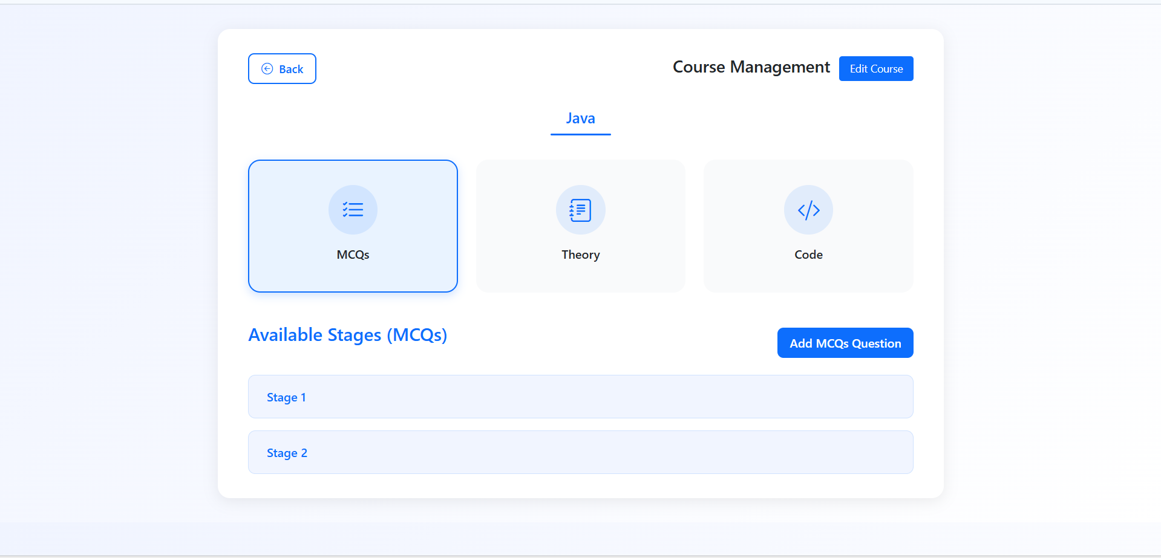

**Add MCQ question**

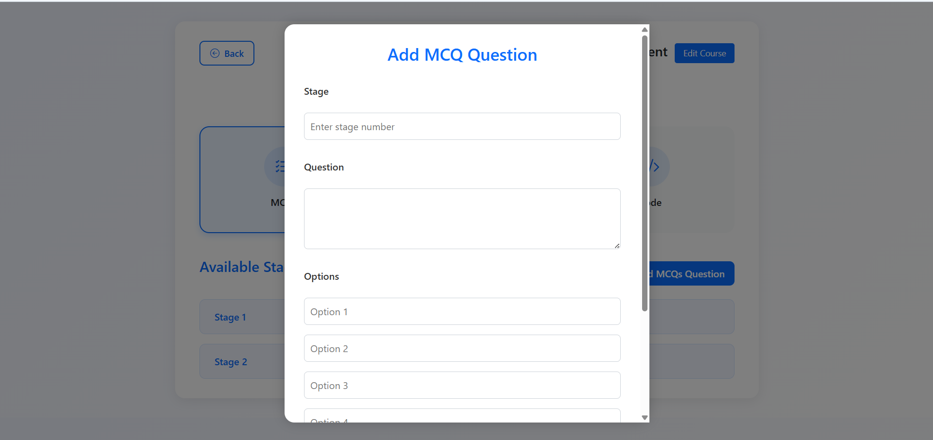

**View / MCQ Questions**

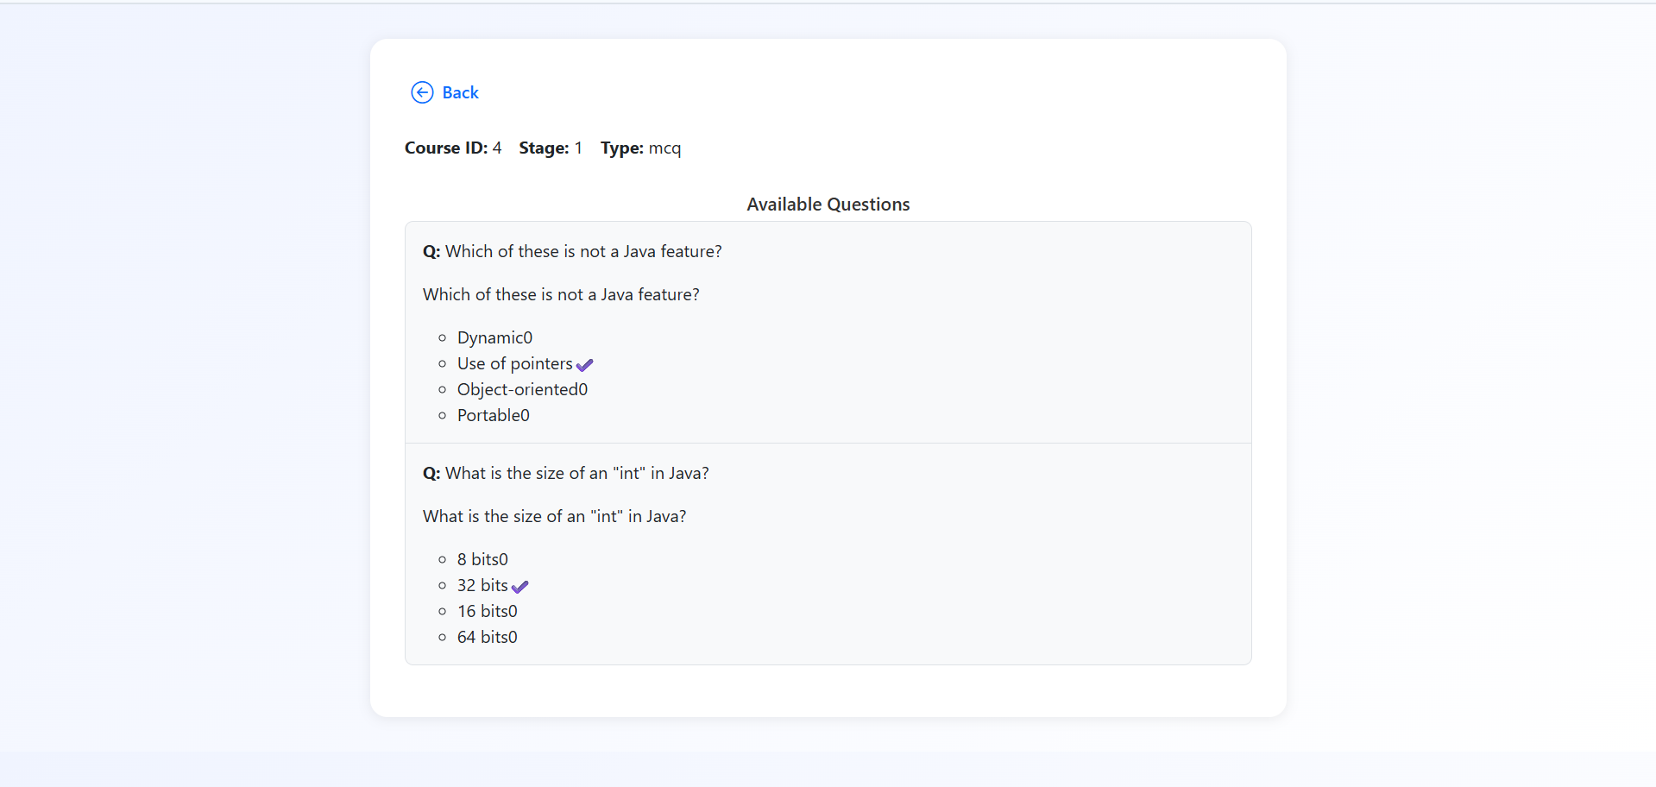

**Add theory questions**

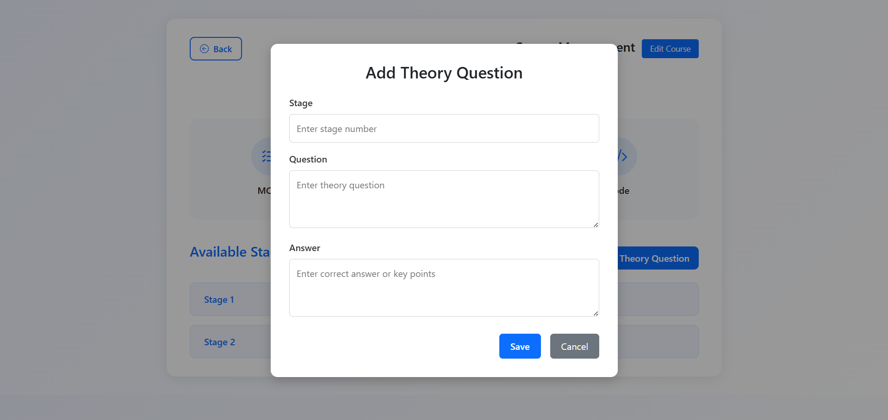

**View Theory Questions:**

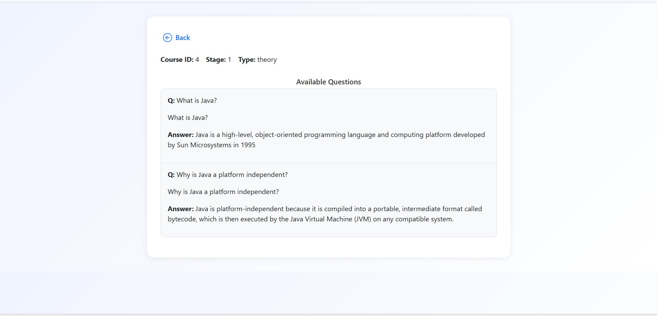

**Add Code Questions:**

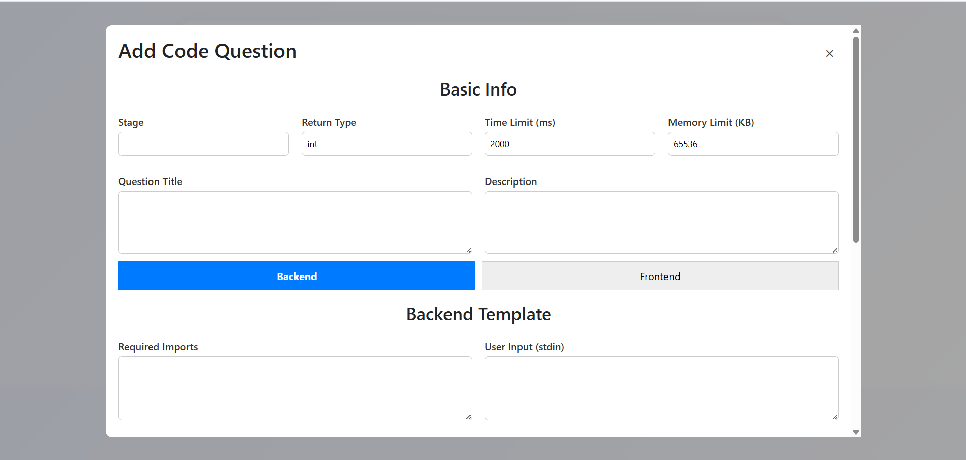

**View Code Questios:**

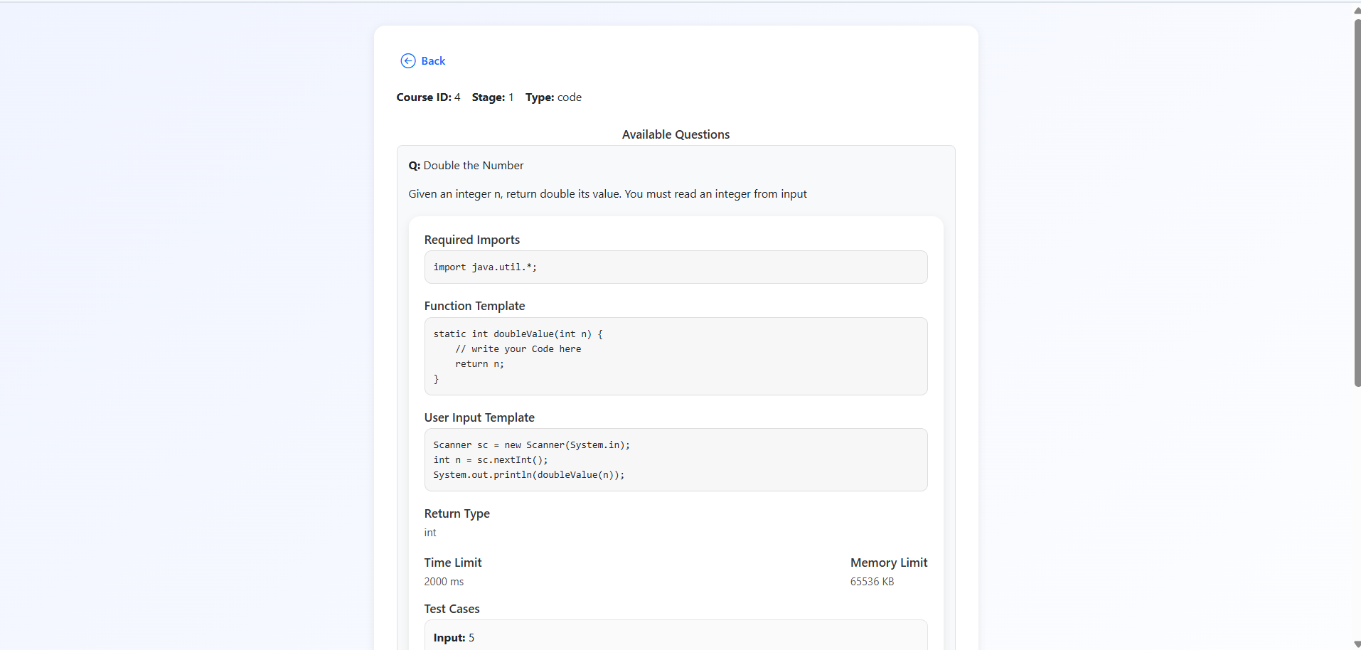

**User Reports:**

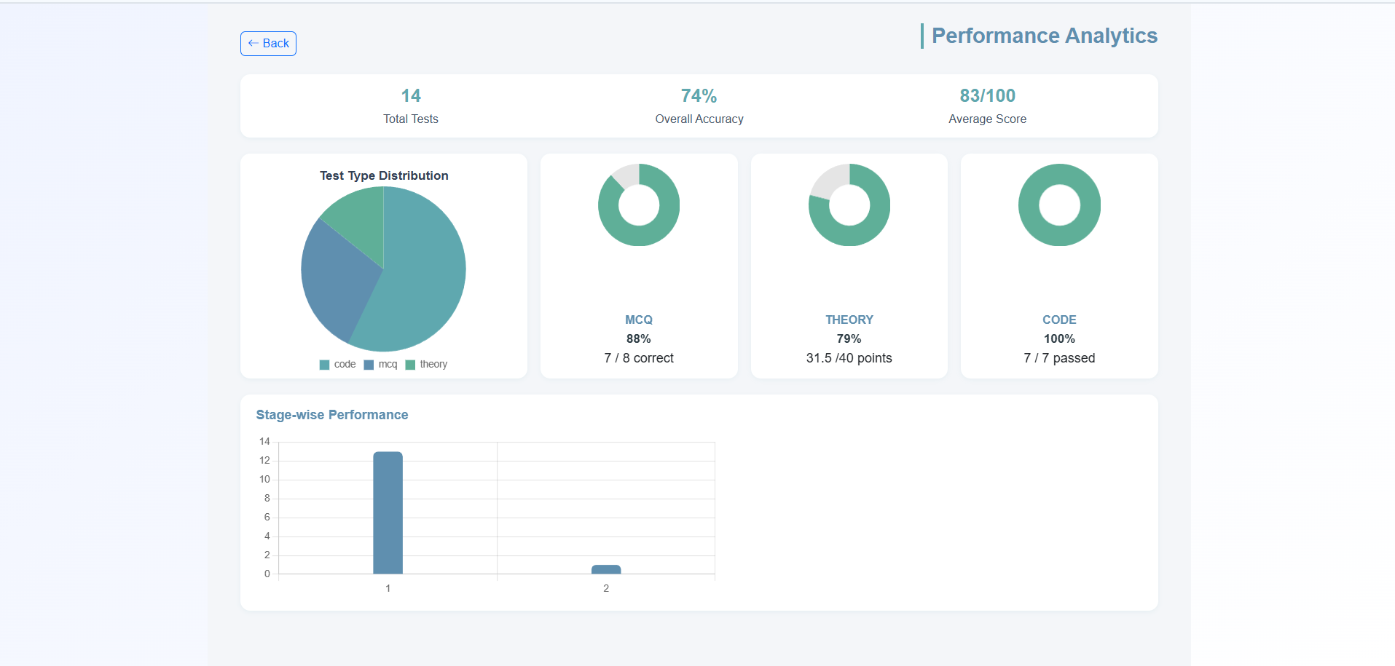

**Chapter: 6**

**Advantages**

**&**

**Limitations.**

# Advantages

* Modern and Scalable Technology Stack: The use of React, Vite, and Supabase makes your application fast, scalable, and easy to maintain. These are popular and in-demand technologies in the web development industry. Simplifies rent collection with automated payment processing and remainders.
* Well-Structured Database: The Xampp MySQL database schema is thoughtfully designed with clear relationships between tables. This makes it easy to manage data and ensures data integrity. Allows users to access the system from anywhere, making property management convenient and flexible.
* Role-Based Access Control: Your application implements a robust role-based access control system, ensuring that users can only access the features and data relevant to their roles. This is a critical security feature for any multi-user platform.
* Comprehensive Feature Set: "Skillify" covers all the essential features for a Skill Assessment Application, from user testing to accurate resultin. This makes it a complete and well-rounded project.

# Limitations

* No Real-time Features: The current implementation doesn't appear to use real-time features. For a skill assessment application, real-time updates are crucial to prevent cheating. Implementing real-time updates using Supabase's real-time capabilities would be a significant improvement.
* Limited Courses Integration: While there are tables for Courses, the courses integration seems basic. A more robust courses system that handles various courses and ensures Efficient testing would be a valuable addition.
* Answers are checked by using Ai: Please note that the answers are evaluated by an AI system and may occasionally contain errors. This is a known limitation of the skill assessment application.

**Chapter: 7**

**Conclusion**

# 7.1 Conclusion

### Conclusion:

Overall, the “Skillify” is an impressive and thoughtfully developed project that reflects a solid grasp of modern software development practices and user-centric design principles. The platform provides a comprehensive solution for evaluating and enhancing user skills through automated assessments and feedback.

With minor improvements—such as refining AI evaluation accuracy and introducing more personalized learning insights—the application has the potential to evolve into an exceptional and highly impactful tool in the field of digital skill development. You should be proud of the quality and functionality you’ve achieved.

**Bibliography:**

**BOOKS:**

1. Abraham Silberschatz, Henry F. Korth, S. Sudarshan, “Database System Concepts”, Edition- 5th, McGraw-Hill.
2. Roger Pressman, “Software Engineering: A Practitioner’s Approach”, edition- 7th, McGraw-Hill.

**Websites:**

1. <http://en.wikipedia.org/wiki/Data_Flow_Diagram>
2. <http://en.wikipedia.org/wiki/ER_diagram>
3. <http://en.wikipedia.org/wiki/Sequence_diagram>
4. <http://www.freetutes.com/systemanalysis/sa2-object-oriented-methodology.html>
5. [www.w3schools.com](http://www.w3schools.com/)